**Q1.**

module clock_divider_by_5_5 (

input clk_in, // Input clock

input reset, // Reset signal

output reg clk_out // Divided output clock

);

reg [3:0] counter; // 4-bit counter for fine-grained control

reg toggle;

always @(posedge clk_in or posedge reset) begin

if (reset) begin

counter <= 4'b0;

clk_out <= 0;

toggle <= 0;

end else begin

if (counter == 4'd10) begin // Total cycles for 5.5 division (approximation)

counter <= 4'b0;

toggle <= ~toggle; // Toggle output every 5.5 input clocks

end else begin

counter <= counter + 1;

end

// Generate clk_out with adjusted duty cycle

if (counter < 4'd5)

clk_out <= toggle;

else

clk_out <= ~toggle;

end

end

endmodule

module tb_clock_divider_by_5_5;

reg clk_in;

reg reset;

wire clk_out;

// Instantiate the clock divider

clock_divider_by_5_5 uut (

.clk_in(clk_in),

.reset(reset),

.clk_out(clk_out)

);

// Generate clock: 10 ns period

initial begin

clk_in = 0;

forever #5 clk_in = ~clk_in; // Toggle every 5 ns

end

// Test procedure

initial begin

reset = 1;

#20; // Hold reset for 20 ns

reset = 0; // Release reset

#2000; // Run simulation for 2000 ns

$stop; // End simulation

end

// Monitor for debug purposes

initial begin

$monitor("Time=%0d, Counter=%d, clk_in=%b, clk_out=%b",

$time, uut.counter, clk_in, clk_out);

end

endmodule  
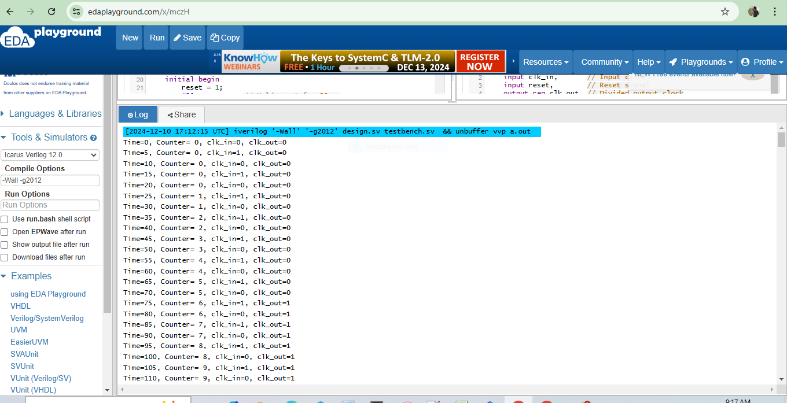

**Q2.**

module ECL (

input clk, // Clock signal

input rst, // Reset signal

input button0, // Button 0 input

input button1, // Button 1 input

input button2, // Button 2 input

output reg open // Output signal

);

// State Encoding

typedef enum reg [2:0] {

S0 = 3'b000, // Initial state

S1 = 3'b001, // Received '2'

S2 = 3'b010, // Received '20'

S3 = 3'b011, // Received '201'

S4 = 3'b100 // Sequence complete, open

} state_t;

state_t current_state, next_state;

// State Transition Block (Sequential Logic)

always @(posedge clk or posedge rst) begin

if (rst) begin

current_state <= S0; // Reset to initial state

end else begin

current_state <= next_state;

end

end

// Next State Logic (Combinational Logic)

always @(*) begin

// Default values

next_state = current_state;

open = 0;

case (current_state)

S0: if (button2) next_state = S1; // Input = 2

S1: if (button0) next_state = S2; // Input = 0

S2: if (button1) next_state = S3; // Input = 1

S3: if (button0) next_state = S4; // Input = 0

S4: begin

open = 1; // Unlock the lock

next_state = S0; // Reset to initial state

end

endcase

end

endmodule

module tb_ECL;

reg clk, rst;

reg button0, button1, button2;

wire open;

// Instantiate the ECL module

ECL uut (

.clk(clk),

.rst(rst),

.button0(button0),

.button1(button1),

.button2(button2),

.open(open)

);

// Clock Generation

initial begin

clk = 0;

forever #5 clk = ~clk; // 10 ns clock period

end

// Test Sequence

initial begin

// Initialize inputs

rst = 1; button0 = 0; button1 = 0; button2 = 0;

#10; rst = 0;

// Apply sequence: 2 -> 0 -> 1 -> 0

#10; button2 = 1; // Input '2'

#10; button2 = 0; button0 = 1; // Input '0'

#10; button0 = 0; button1 = 1; // Input '1'

#10; button1 = 0; button0 = 1; // Input '0'

#10; button0 = 0;

// Wait and stop simulation

#50;

$finish;

end

// Monitor for Debugging

initial begin

$monitor("Time=%0d, rst=%b, button0=%b, button1=%b, button2=%b, open=%b, state=%b",

$time, rst, button0, button1, button2, open, uut.current_state);

end

endmodule

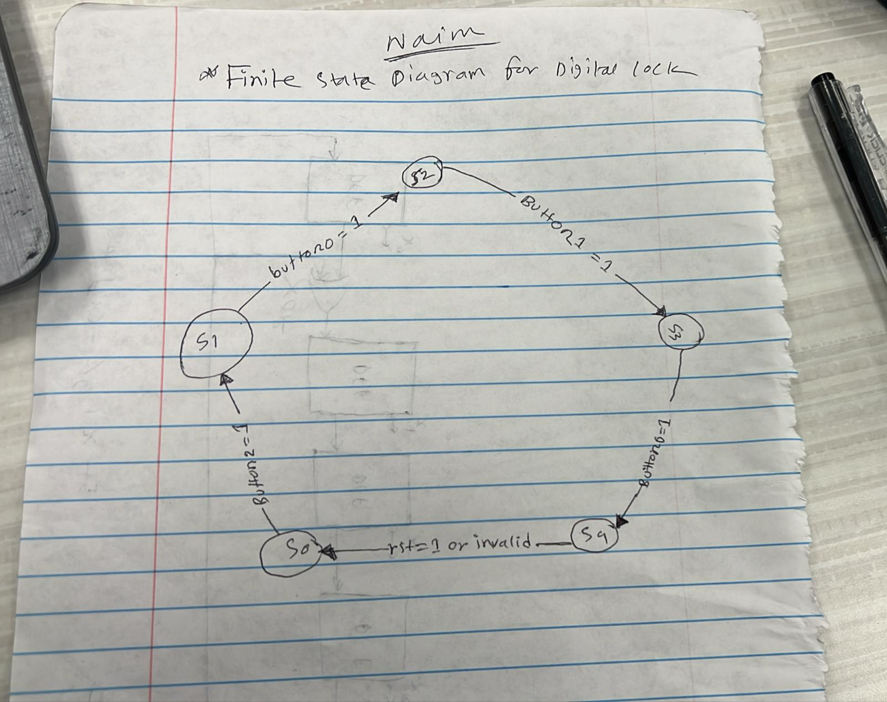

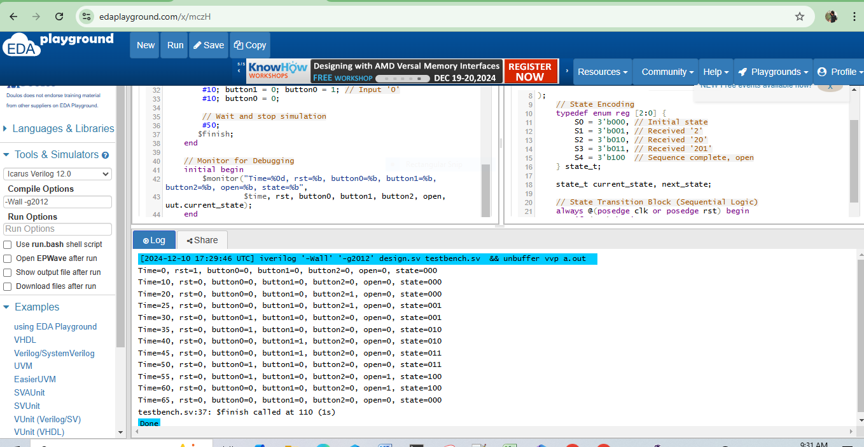

**Q3.**

module crc6_encoder (

input clk, // Clock signal

input rst, // Reset signal (synchronous)

input serial_in, // Serial input data

output reg [5:0] crc // CRC remainder (6 bits)

);

// Polynomial: x^6 + x + 1 (1000011)

wire feedback;

// Feedback Calculation

assign feedback = crc[5] ^ serial_in;

// CRC Shift Register

always @(posedge clk or posedge rst) begin

if (rst) begin

crc <= 6'b0; // Reset CRC to 0

end else begin

// Shift and XOR based on feedback

crc <= {crc[4:0], feedback}; // Shift left and add feedback

crc[1] <= crc[1] ^ feedback; // Polynomial term for x^1

end

end

endmodule  
module tb_crc6_encoder;

reg clk; // Testbench clock

reg rst; // Testbench reset

reg serial_in; // Testbench serial input

wire [5:0] crc; // CRC output

// Instantiate the CRC-6 Encoder

crc6_encoder uut (

.clk(clk),

.rst(rst),

.serial_in(serial_in),

.crc(crc)

);

// Clock Generation

initial begin

clk = 0;

forever #5 clk = ~clk; // 10 ns clock period

end

// Test Sequence

initial begin

// Initialize inputs

rst = 1; serial_in = 0;

#10; rst = 0;

// Apply test data (example: 1011001)

#10; serial_in = 1; // Bit 1

#10; serial_in = 0; // Bit 2

#10; serial_in = 1; // Bit 3

#10; serial_in = 1; // Bit 4

#10; serial_in = 0; // Bit 5

#10; serial_in = 0; // Bit 6

#10; serial_in = 1; // Bit 7

// End simulation

#50;

$finish;

end

// Monitor CRC for debugging

initial begin

$monitor("Time=%0d | serial_in=%b | crc=%b", $time, serial_in, crc);

end

endmodule  
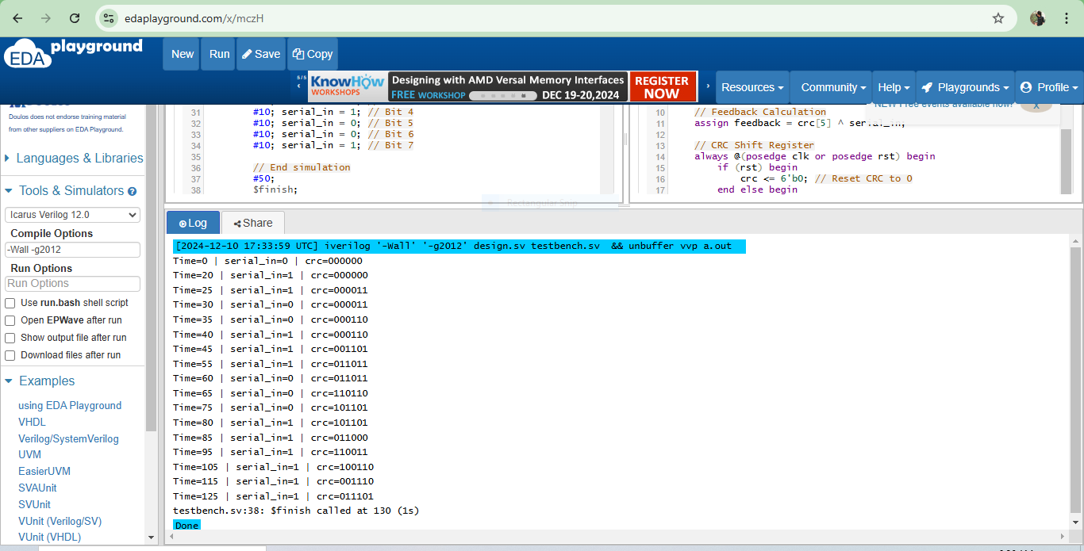

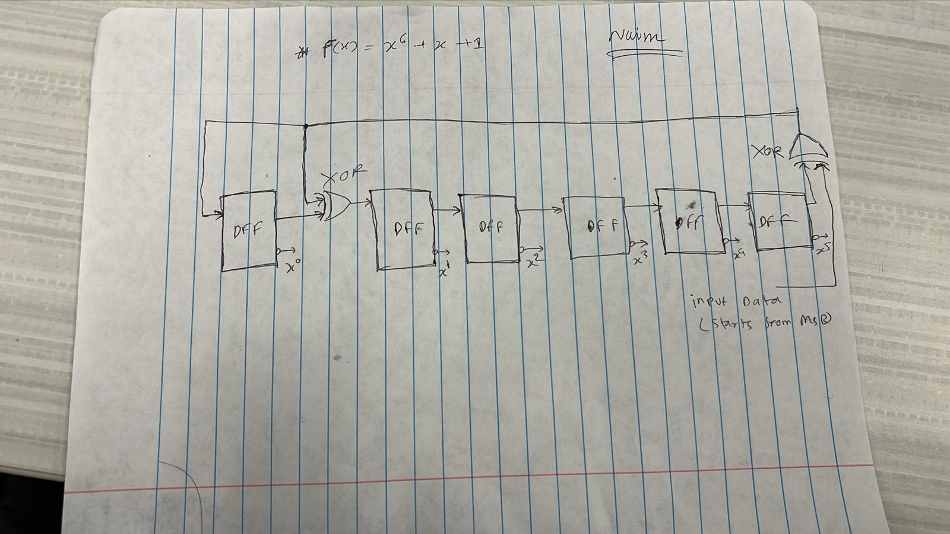

**Q4.**

module dual_clock_fifo (

input wire clk_tx, // Transmitter clock

input wire clk_rx, // Receiver clock

input wire rst, // Reset signal (active high)

input wire write_enable, // Write enable signal

input wire read_enable, // Read enable signal

input wire [7:0] data_in, // 8-bit data input

output reg [7:0] data_out, // 8-bit data output

output reg full, // FIFO full flag

output reg empty // FIFO empty flag

);

parameter DEPTH = 16; // Depth of the FIFO

parameter ADDR_WIDTH = 4; // Address width for FIFO indexing

reg [7:0] fifo_mem [DEPTH-1:0]; // FIFO memory array

reg [ADDR_WIDTH-1:0] write_ptr; // Write pointer

reg [ADDR_WIDTH-1:0] read_ptr; // Read pointer

reg [ADDR_WIDTH:0] fifo_count; // Counter for number of elements in FIFO

// Reset and Initialization

always @(posedge clk_tx or posedge clk_rx or posedge rst) begin

if (rst) begin

write_ptr <= 0;

read_ptr <= 0;

fifo_count <= 0;

empty <= 1;

full <= 0;

end

end

// Write Logic

always @(posedge clk_tx) begin

if (write_enable && !full) begin

fifo_mem[write_ptr] <= data_in; // Write data to FIFO

write_ptr <= write_ptr + 1;

fifo_count <= fifo_count + 1;

empty <= 0;

full <= (fifo_count == DEPTH - 1); // Set full flag

end

end

// Read Logic

always @(posedge clk_rx) begin

if (read_enable && !empty) begin

data_out <= fifo_mem[read_ptr]; // Read data from FIFO

read_ptr <= read_ptr + 1;

fifo_count <= fifo_count - 1;

full <= 0;

empty <= (fifo_count == 1); // Set empty flag

end

end

// Full and Empty Flags

always @(posedge clk_tx or posedge clk_rx) begin

full <= (fifo_count == DEPTH);

empty <= (fifo_count == 0);

end

endmodule  
module tb_dual_clock_fifo;

reg clk_tx; // Transmitter clock

reg clk_rx; // Receiver clock

reg rst; // Reset signal

reg write_enable; // Write enable

reg read_enable; // Read enable

reg [7:0] data_in; // Data input to FIFO

wire [7:0] data_out; // Data output from FIFO

wire full; // FIFO full flag

wire empty; // FIFO empty flag

// Instantiate the Dual-Clock FIFO

dual_clock_fifo uut (

.clk_tx(clk_tx),

.clk_rx(clk_rx),

.rst(rst),

.write_enable(write_enable),

.read_enable(read_enable),

.data_in(data_in),

.data_out(data_out),

.full(full),

.empty(empty)

);

// Generate Transmitter Clock: 50 MHz (20 ns period)

initial begin

clk_tx = 0;

forever #10 clk_tx = ~clk_tx;

end

// Generate Receiver Clock: 80 MHz (12.5 ns period)

initial begin

clk_rx = 0;

forever #6.25 clk_rx = ~clk_rx;

end

// Test Sequence

initial begin

// Initialize signals

rst = 1;

write_enable = 0;

read_enable = 0;

data_in = 0;

#50; rst = 0; // Release reset after 50 ns

// Write 20 data words to FIFO

repeat (20) begin

@(posedge clk_tx);

write_enable = 1;

data_in = $random % 256; // Random 8-bit data

@(posedge clk_tx);

write_enable = 0;

end

// Read 20 data words from FIFO

repeat (20) begin

@(posedge clk_rx);

read_enable = 1;

@(posedge clk_rx);

read_enable = 0;

end

// End simulation

#200;

$finish;

end

// Monitor Outputs

initial begin

$monitor("Time=%0d | data_in=%b | data_out=%b | full=%b | empty=%b",

$time, data_in, data_out, full, empty);

end

endmodule  
